| | Team name | 6droids | | --- | --- | | 14208971 | Tharkana D Kodagoda | | 14208893 | Sahitha Nelanga H De Silva | | 14208910 | H W Srimal Priyanga Fonseka | | 14209059 | Dilina Namal Weerasinghe | | 14209074 | P W Poorni Yasodara | | 14209759 | Kavindu Yudeesha Lakshan Narathota | |
| --- | --- | --- | --- | --- | --- | --- | --- | --- | --- | --- | --- | --- | --- | --- |
| Assignment – Object Oriented Design (COMP3004L) |
| UML Diagrams for Switch and Rummy card games Final Report |



Contents

**Introduction**

**1.** **User case Diagram**

**2.** **State Diagram**

**3.** **Sequence Diagram**

**4.** **Domain Analysis**

**6.** **Object Diagram**

**7.** **Deployment Diagram**

**Introduction**

This Report is a collection of UML diagrams which will give a complete example of Object Oriented Analysis, Design and Programming applied to 2 simple card games, Switch and Rummy!

In this case we studied all the possible ways of winning each game and came up with the optimal solution to get the best outcome.

1. **User case Diagram**

C:\Users\Kavindu Narathota\AppData\Local\Microsoft\Windows\INetCache\Content.Word\Usecase Diagram Update - 2.png

*Figure 1 - Use Case Diagram*

1. **State Diagram**

C:\Users\Kavindu Narathota\AppData\Local\Microsoft\Windows\INetCache\Content.Word\State Diagram - 1.png

*Figure 2 - State Diagram*

State Diagram - 2 (Rummy).png

*Figure 3 - State Diagram (Rummy)*

State Diagram - 3 (Switch).png

*Figure 4 - State Diagram (Switch)*

1. **Sequence Diagram**

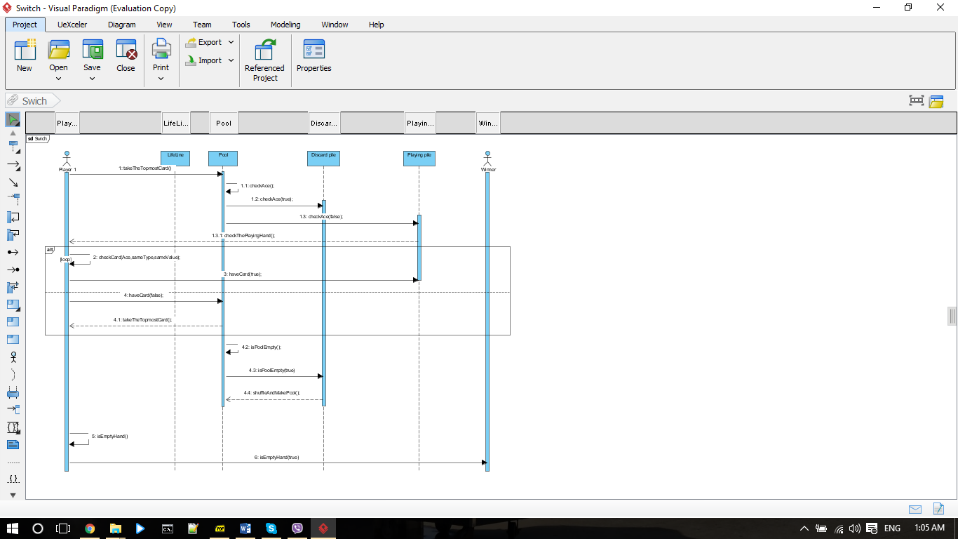

*Figure 5 - Sequence Diagram (Switch)*

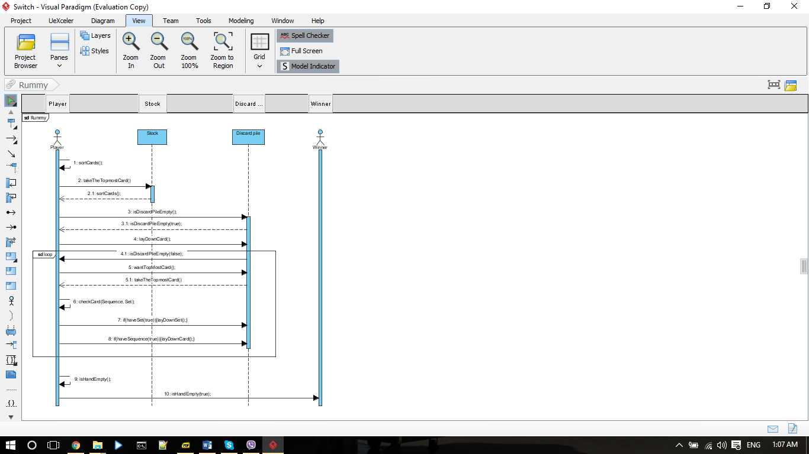

*Figure 6 - Sequence Diagram (Rummy)*

1. **Domain Analysis**

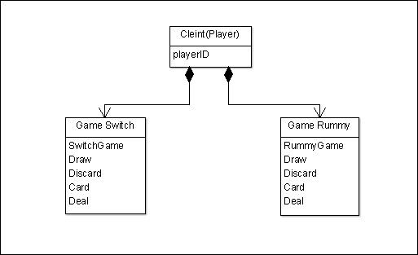

*Figure 7 - Domain Analysis*

Below mentioned parts of the system were suggested by an initial reading of the Activity and Use Case diagrams.

* A controller object will represent the card game software.
* The individual component parts of the Card Game Software will be represented by Boundary objects.
* Rummy GUI
* Switch GUI
* Controller objects corresponding to use cases.
* Switch Game
* Rummy Game
* Server
* The information of players inserted by player will be represented by an entity object.
* The log of game history which is represented by an entity object will be maintained by the system.

1. **Class Diagram**



*Figure 8 - Class Diagram*

1. **Object Diagram**



*Figure 9 - Object Diagram (Rummy)*



*Figure 10 - Object Diagram (Switch)*

1. **Deployment Diagram**



*Figure 12 - Deployment Diagram*